

**School of Computing**

**and**

**Digital Technologies**

**Software Projects**

**(55-407815-AF-20245)**

**Group Project**

|  |  |  |
| --- | --- | --- |
| **Name** | **ID** | **Degree Route** |
| Bogdan Dinulescu | 4023190 | BEng Software Engineering |
| Bolu Fagbolagun | 34053497 | BEng Software Engineering |
| Tyrese Fairweather | 34009423 | BEng Software Engineering |
| Abdulahi Hassan | 4003036 | BEng Software Engineering |
| Laurie Layland | 4018915 | BEng Software Engineering |
| Jed Patterson | 34018024 | BEng Software Engineering |

Table of Contents

3. Group Project 3

3.1 Client Background 3

3.2 Software Project Artefacts 3

3.2.1 Users 3

3.2.2 User Stories and Acceptance Tests 3

3.2.3 Entity Relationship Diagram 5

3.3 Software and Its Presentation 5

3.3.1 The Software Prototype 5

3.3.2 Video Presentation 5

3.4 Evidence of Collaborative Work 5

3.5 Incorporation of Formative Feedback 5

3.6 Peer Assessment Form 5

4. Evaluative Report on Legal, Social, Ethical and Professional Issues 5

4.1. Relevant Issues 5

4.2. Discussion 6

5. References 6

Appendix 7

Software Projects- Peer Marking Form 7

# 3. Group Project

## 3.1 Client Background

Our client is Mrs. Nurul Izrin Md Saleh, from Malaysia. She has commisioned us to construct a smart energy management dashboard that may be used by local government.

## 3.2 Software Project Artefacts

### 3.2.1 Users

The users are as follows; an administrator, who has access to every feature and can manage the system, such as by adding and removing other users; network managers, who can access ordinary features and create reports for all geographical areas; and city councillors, who can access ordinary features only for the geographic area within which they operate.

### 3.2.2 User Stories and Acceptance Tests

|  |  |  |
| --- | --- | --- |
| **ID** | **Story** | **Acceptance tests** |
| ADM-01 | As an administrator, I want a special controls dashboard so I can manage the system. | * Verify administrator account can access controls dashboard * Verify non-administrator cannot access controls dashboard * Verify administrator can add a user * Verify administrator can remove a user |
| ADM-02 | As an administrator, I want to be able to view all data within the system. | * Verify administrator can view energy usage for the entire system * Verify administrator can access analytics for the entire system * Verify administrator can generate reports for the entire system |
| NET-01 | As a network manager, I want to be able to view all data within my network. | * Verify network manager can view energy usage for own network * Verify network manager can access analytics for own network * Verify network manager can generate reports for own network * Verify network manager cannot view or process data outside of own network |
| NET-02 | As a network manager, I want to be able to compare and contrast energy consumption over different time periods. | * Verify network manager can layer multiple energy consumption graphs * Verify reports can include layered graphs * Verify network manager can specify time period for these overlays |
| NET-03 | As a network manager, I want all of the analysis tools available to city councillors to be available to me also. (Note: still only for own network) | * Verify network manager can use interactive dashboard as city councillor can (CIT-02) |
| CIT-01 | As a city councillor, I want to be able to view all data within my network. | * Verify councillor can view energy usage for own network * Verify concillor can access analytics for own network * Verify councillor can generate reports for own network * Verify councillor cannot view or process data outside of own network |
| CIT-02 | As a city councillor, I want an interactive dashboard to make it easy to interact with the system. | * Verify user is presented with interactive dashboard * Verify dashboard links to analytics * Verify dashboard links to reports |
| CIT-03 | As a city councillor, I want all of the analysis tools available to network managers to be available to me also. (Note: still only for own citty) | * Verify network manager can compare and contrast energy consumption as city councillor can (NET-02) |

### 3.2.3 Use Case Diagram

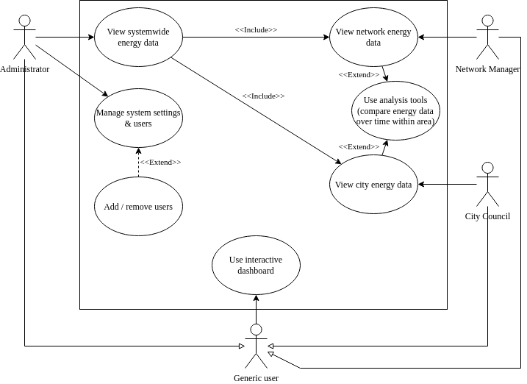

### 3.2.4 Entity Relationship Diagram

## 3.3 Software and Its Presentation

### 3.3.1 The Software Prototype

You are expected to submit the project, including all of its components (e.g., codebase), compressed in a zip file (or 7z). The file should be named “GroupProject_(Your name)” (i.e., *GroupProject_Group21*) and must be uploaded to Blackboard as directed in the relevant submission point.

### 3.3.2 Video Presentation

The project must be showcased in a video recording of up to 15 minutes. We will stop watching after the 15th minute.

<https://shu.cloud.panopto.eu/Panopto/Pages/Viewer.aspx?id=b35aedd7-0a14-401c-b664-b26b00ba566b>

## 3.4 Evidence of Collaborative Work

https://github.com/JedPattersonn/SHU-Project

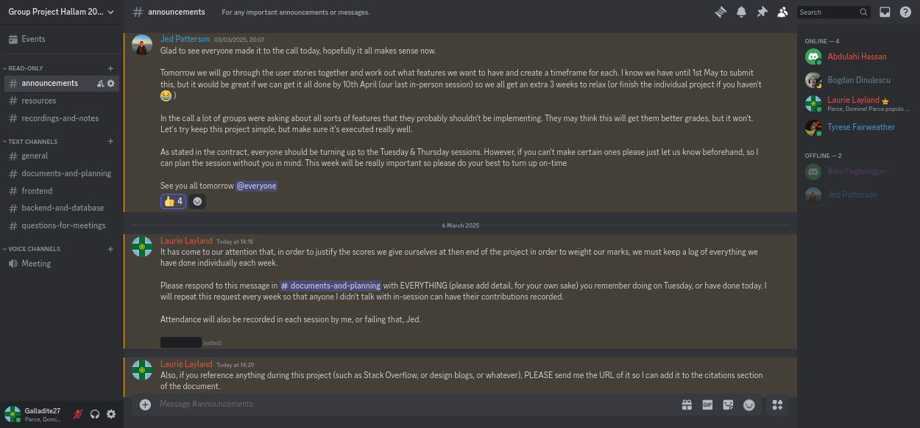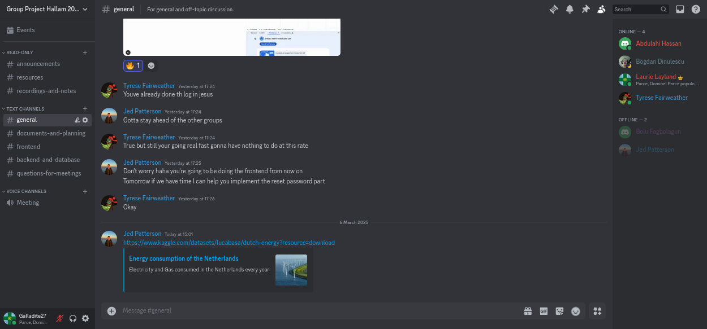

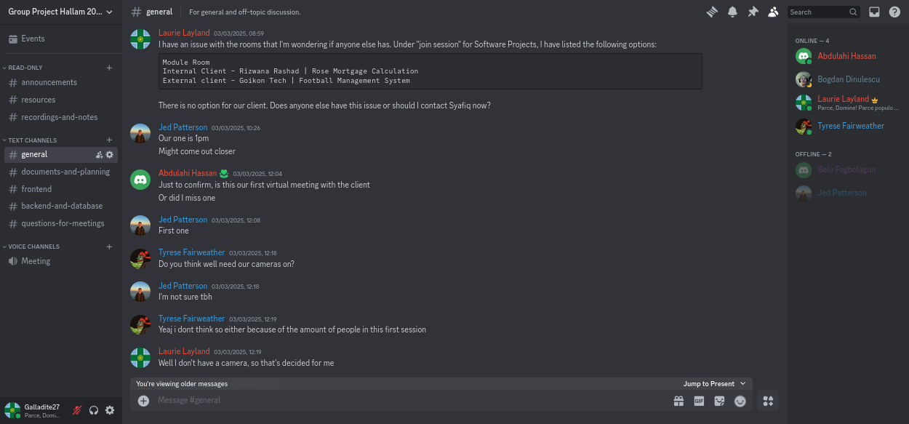

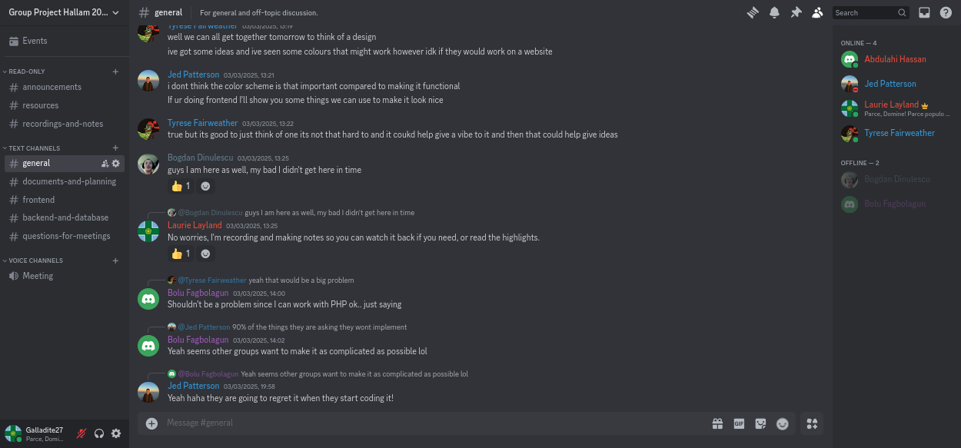

## 3.5 Incorporation of Formative Feedback

Provide evidence of how you evaluated and acted on the formative feedback you received from your client, e.g., minutes of meeting, copies of emails, together with action plan.

Meeting notes

|  |  |
| --- | --- |
| **Note** | **Action plan** |
| **10.iii.25** |  |
| Use heat maps to display data | Add to todo list that a heat map needs implementing. Find a library to use. Implement the heatmap ASAP with placeholder data. |
| It’s fine to display historical data on the dashboard | No action needed, but question clarified. |
| Display at least 10 cities’ data for the prototype | Only process and validate 10 cities’ worth of data to save on processing time and file sizes (for the sake of testing). |
| For the OTP, use e-mail authentication | Add to todo list to implement e-mail authentication. Ensure 2FA is configured to allow a code to be sent through e-mail later on. |
| When the admin adds users, ensure the appropriate city / network for the new user can be selected | No immediate action needed, but plan to add this option when the admin dashboard is created. |
| **17.iii.25** |  |
| The client wants to see the registration screen (for new users) | Prioritise developing the system for adding new users before the next meeting (which won’t be until 7th April, so there is ample time to polish). |
| The client wants to see the dashboard from the perspective of the users | Prioritise developing the aspects of the dashboard which are changeable based on the user’s role before the next meeting (see above note). |
| For the heatmap, the client wants to see the consumption of an area when it is clicked on | Add to todo list to ensure the heatmap is clickable (lower priority than the above two points, since those were specifically requested to be displayed). |
| The next meeting will be on 7th April due to a malaysian holiday | No action needed, except to mark the calendar. |

## 3.6 Peer Assessment Form

This form must be filled in as a group. Each member’s contribution to the project must be clearly stated. Finally, each member must be rated out of 10 (10 being the highest contribution and 0 being no contribution at all). This form can be added to Appendix.

# 4. Evaluative Report on Legal, Social, Ethical and Professional Issues

## 4.1. Relevant Issues

Identify two or three issues that specifically relate to your project (this could be GDPR, copyright, accessibility, testing, etc.), and briefly explain their relevance to your project.

## 4.2. Discussion

Discuss what impact these will have on the project. Specifically, you may discuss how these issues will impact on the way you will transition your prototype / design you developed in Requirements and Design stage to a production-quality (where possible). As well as supporting your discussion with references, throughout your work you are also expected to identify recent public examples that have been reported in the news (or other reputable sources), for example if you are creating an application that will store personal data, a useful example would be to mention the fine British Airways received for being in breach of GDPR, all of which should be cited using the APA format.

Quick notes on things we’ve done before I write this up:

* Hashing passwords (legal)
* Resetting passwords (social – people are forgetful)

# 5. References

(APA referencing)

Fitzgerald, J., & Hayward, P. (2009). Inflamed: Synthetic folk music and paganism in the island world of The Wicker Man. In P. Hayward (Ed.), Terror tracks: Music, sound and horror cinema (pp. 101-111). London: Equinox. **(PLACEHOLDER ONLY)**

# Appendix

## Software Projects - Peer Marking Form

This form must be filled in as a group by honestly evaluating your contribution to the work. Each member’s contribution to the project must be clearly stated. Finally, each member must be rated out of 10 (10 being the highest contribution and 0 being no contribution at all). The highest mark must always be 10, e.g.

|  |  |  |
| --- | --- | --- |
|  | Team member + work done | Mark out of 10 |
| 1 | B D – | X / 10 |
| 2 | B F – | X / 10 |
| 3 | T F – | X / 10 |
| 4 | A H – | X / 10 |
| 5 | L L – | X / 10 |
| 6 | J P – | X / 10 |



|  |
| --- |
| Add any comments you feel would be useful for the tutor to know about when assessing marks |
| With regards to the prototype development, work was split 50-50 between C H and O H, with C H responsible for the backend and O H for UI. This was not as intended, as the spec states that all should contribute to programming tasks – unfortunately despite repeated efforts we could not get E S to contribute in any way to the prototype, and we were never able to even contact S T. As such, O H and C H took on significantly more work than originally planned due to the other two members not fulfilling any of their responsibilities, with both O H and C H frequently working into the night to complete the coding that should’ve been done by the other two members.    E H made a contribution on the day of hand-in by completing one of the scenario scripts he was supposed to complete: S T never turned up. As such, this project was almost entirely completed solely by C H and O H, with E S’s contribution minimal and S T’s non-existent. This had a significant impact on the time taken to complete with O H and C H having to make up everyone else’s work as well as their own and has impacted on the project significantly. |

|  |  |  |
| --- | --- | --- |
|  | Team member + work done | Mark out of 10 |
| 1 | **B D**  **Week 1:**  Tuesday: discussed role distribution and agreed to focusing on helping with the backend, researched and did some learning of the basics of Next JS  Thursday: continued learning  **Week 2:**  Tuesday: continued learning  Thursday: continued learning, installed MySQL workbench ready to help with database  **Week 3:**  Tuesday: not recorded  Thursday: absent | X / 10 |
| 2 | **B F**  **Week 1:**  Tuesday: discussed role distribution and agreed to focusing on the database  Thursday: begun analysing provided dataset and planning for conversion using a script (PHP?) into our database format, pending the ERD’s production  **Week 2:**  Tuesday: reviewed with Jed what needed doing with the database and started working on ERD  Thursday: finalised schema for the database with Jed  **Week 3:**  Tuesday: not recorded  Thursday: absent | X / 10 |
| 3 | **T F**  **Week 1:**  Tuesday: discussed role distribution and agreed to focusing on the frontend, created non-clickable first version of the wireframe  Thursday: worked on the frontend with Jed, planning what ought to go on the home page (dashboard) and the visibility of each element to different user types  **Week 2:**  Tuesday: absent  Thursday: Started on charts within webapp frontend, but still has to wait for database to be populated for testing in order to continue  **Week 3:**  Tuesday: not recorded  Thursday: absent | X / 10 |
| 4 | **A H**  **Week 1:**  Tuesday: discussed role distribution and agreed to focusing on helping with documentation (particularly the diagrams) while they need doing  Thursday: began constructing the use case diagram based on the completed set of user stories and acceptance tests  **Week 2:**  Tuesday: completed and presented to group a use case diagram  Thursday: not recorded  **Week 3:**  Tuesday: absent  Thursday: absent | X / 10 |
| 5 | **L L**  **Week 1:**  In advance: cloned Git repository, accepted contributor invite, created Discord server for the group and configured with roles and channels  Monday: recorded client meeting, notified absent group members to join  Tuesday: added this document to the Git repository so changes can be tracked, added information such as names to this document, identified client background and users, identified nine use case stories – three per user – each with at least three acceptance tests, discussed group roles in this project and assigned roles in the Discord server  Thursday: begun logging information in this peer marking form, begun recording group member attendance, sent message to all group members and spoke in person with everyone when they were free to try and work out a list of what everyone had already done, sent reminder to everyone to share any resources referenced so they could be cited in this document, took screenshots of the discord server and git repository as evidence of collaborative working  **Week 2:**  Monday: recorded and shared notes from the client meeting  Tuesday: recorded work done in this document, added team contract to git repository, modified gitignore, did research to learn certain git commands required to carry out these changes  Thursday: refactored ERD produced by Abdulahi, presented it to the group for approval, recorded work done in this document, added use case diagrams to git repository, added use case diagram to this document, configured webhook on the Discord server so group members are notified whenever there is activity on the Github repository  **Week 3:**  Tuesday: not recorded  Thursday: absent | X / 10 |
| 6 | **J P**  **Week 1:**  In advance: created a whatsapp group chat for initial organisation (we soon moved to Discord, however), created Github repository, created Trello board for planning and time management  Tuesday: spearheaded organisation and role distribution, invited group members to Github and Trello resources, created first version of login page with 2FA for the website, hosted the site with Vercel  Thursday: continued working on frontend with Tyrese, planning what ought to go on the home page (dashboard) and the visibility of each element to different user types  **Week 2:**  Tuesday: implemented sidebar for the working version of the web app, with buttons, user information, and a content section taking most of the page with placeholder text, implemented basic heatmap ready to plot data to, some more UI development  Thursday: worked more on frontend, finalised database schema with Bolu  **Week 3:**  Tuesday: not recorded  Thursday: absent | X / 10 |



|  |
| --- |
| Add any comments you feel would be useful for the tutor to know about when assessing marks |
|  |